# Brainstorm

**TIP**

You can select a sticky note and hit the pencil [switch to sketch] icon to start drawing!

### Before you collaborate

A little bit of preparation goes a long way with this session. Here’s what you need to do to get going.

**10 minutes**

**1**

### Define your problem statement

What problem are you trying to solve? Frame your problem as a How Might We statement. This will be the focus of your brainstorm.

**5 minutes**

**2**

### Brainstorm

Write down any ideas that come to mind that address your problem statement.

**10 minutes**

**3**

### Group ideas

Take turns sharing your ideas while clustering similar or related notes as you go. Once all sticky notes have been grouped, give each cluster a sentence-like label. If a cluster is bigger than six sticky notes, try and see if you and break it up into smaller sub-groups.

**20 minutes**

**4**

### Prioritize

Your team should all be on the same page about what's important moving forward. Place your ideas on this grid to determine which ideas are important and which are feasible.

**20 minutes**

### After you collaborate

You can export the mural as an image or pdf to share with members of your company who might find it helpful.

**Quick add-ons**

# & idea prioritization

**PROBLEM**

An Advanced Smart crop protection system helps the farmers from preventing crops from damage by animals .The setup should be easy to handle in user friendly android based mobile device.

#### Use this template in your own brainstorming sessions so your team can unleash their imagination and start shaping concepts even if you're not sitting in the same room.

1. Team gathering

Define who should participate in the session and send an invite. Share relevant information or pre-work ahead.

1. Set the goal

Think about the problem you'll be focusing on solving in the brainstorming session.

1. Learn how to use the facilitation tools

Use the Facilitation Superpowers to run a happy and productive session.

PIR sensor detects smoke flame etc and alert farmer

**RASHIKA**

Using low cost software can increase productivity

Alarm can alert farmers

**SANGAVI**

**TIP**

Add customizable tags to sticky notes to make it easier to find, browse, organize, and categorize important ideas as themes within your mural.

Ardino UNO helps to connect with devices

design a Device which could sustain climate changes

Notification will be sent to the user mobile

moisture level can be detected by mobile app

IOT

based Network

python based data to server

**SWETHA**

## 

analyse data from IOT

CNN

Technology can be used

Using low cost software can increase productivity

Sending information when needed

analyse data from IOT

setup in water supply can improve agriculture

PIR sensor detects smoke flame etc and alert farmer

SD Card Module is compatible with maximum micro contollers forums

Alarm can alert farmers

moisture level can be detected by mobile app

SD Card Module is compatible with maximum micro contollers forums

device should feasibile

design a Device which could sustain climate changes

1. Share the mural

**Share a view link** to the mural with stakeholders to keep them in the loop about the outcomes of the session.

1. Export the mural

Export a copy of the mural as a PNG or PDF to attach to emails, include in slides, or save in your drive.

setup LCD Display for the Status and Output

For Irrigation water supply can be Controlled

Flame sensor is most sensitive can be used

For Irrigation water supply can be Controlled

making book for references

Sending information when needed

Solar panel can be used so that device can be charged

Ardino UNO helps to connect with devices

using lr sensors to Detect animals

**10 minutes** to prepare

**1 hour** to collaborate

**2-8 people** recommended

[**Open article**](https://support.mural.co/en/articles/2113740-facilitation-superpowers)

Use of low cost devices can increase in productivity

**Key rules of brainstorming**

To run an smooth and productive session

**SNEHA**

Flame sensor is most sensitive can be used

python based data to server

setup LCD Display for the Status and Output

setup LCD Display for the Status and Output

## 

setup in water supply can improve agriculture

Electric fence can be avoided

**POOJALAKSHMI**

PIR sensor detects smoke flame etc and alert farmer

Ardino UNO helps to connect with devices

**Keep moving forward**

Strategy blueprint

Define the components of a new idea or strategy.

[Open the template](https://app.mural.co/template/e95f612a-f72a-4772-bc48-545aaa04e0c9/984865a6-0a96-4472-a48d-47639307b3ca)

**Customer experience journey map**

device should feasibile

Stay in topic. Defer judgment.

design a Device which could sustain climate changes

human also cannot enter without permission

using lr sensors to Detect animals

Scarecrow can be avoided

Encourage wild ideas. Listen to others.

##### Importance

If each of these

Understand customer needs, motivations, and obstacles for an experience.

[**Open the template**](https://app.mural.co/template/b7114010-3a67-4d63-a51d-6f2cedc9633f/c1b465ab-57af-4624-8faf-ebb312edc0eb)

photocopies will be stored in application

ALARM Can

Alert the Farmer

Go for volume. If possible, be visual.

photocopies will be stored in application

tasks could get

done without any difficulty or cost, which would have the most positive impact?

Strengths, weaknesses, opportunities & threats

Identify strengths, weaknesses, opportunities, and threats (SWOT) to develop a plan.

Sending information when needed

|  |  |
| --- | --- |
|  |  |
|  |  |

[Open the template](https://app.mural.co/template/6a062671-89ee-4b76-9409-2603d8b098be/ca270343-1d54-4952-9d8c-fbc303ffd0f2)

Movement of the animals can be detected using motion Sensor

TIP

Participants can use their cursors to point at where sticky notes should go on the grid. The facilitator can confirm the spot by using the laser pointer holding the **H key** on the keyboard.

[Share template feedback](https://muralco.typeform.com/to/CiqaHVat?typeform-source=app.mural.co)

[**Share template feedback**](https://muralco.typeform.com/to/CiqaHVat?typeform-source=app.mural.co)

##### Feasibility

Regardless of their importance, which tasks are more feasible than others? (Cost, time, effort, complexity, etc.)

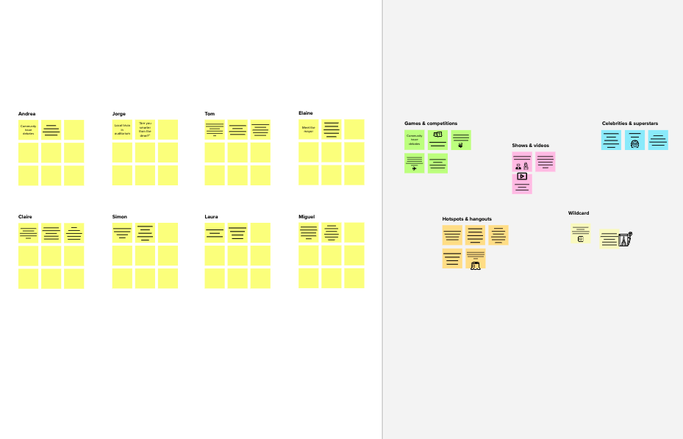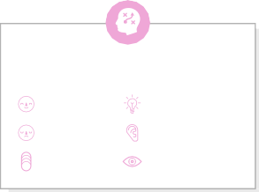

**Template**

###### Need some inspiration?

See a finished version of this template to kickstart your work.

[Open example](https://app.mural.co/template/e5a93b7b-49f2-48c9-afd7-a635d860eba6/93f1b98d-b2d2-4695-8e85-7e9c0d2fd9b9)